State Leadership Conference Registration and Event Management System
Instruction Guide

Log In
Website: https://www.registermychapter.com/fccla/mt

- Username: Chapter ID
- Password: Same password you use to log into the membership affiliation system
Nicole can email you this information.

Registration closes Wednesday, February 8.

What if I can’t register everyone at once?
- That’s okay! You can click on ‘finish processing later’ at the top of most screens. This will allow you to save your work and log in to finish at a later time.
- You can also ‘finish registering’ and then log back in to update any information. This includes making changes to events and adding/deleting attendees. Just be sure to ‘finish registering’ again to finalize the edits and print an updated invoice.

Verification

This screen is to verify your chapter and adviser information. It will only appear the first time you log in. You will be asked to verify that your chapter will follow the SLC policies including dress code, code of conduct, and lodging. | 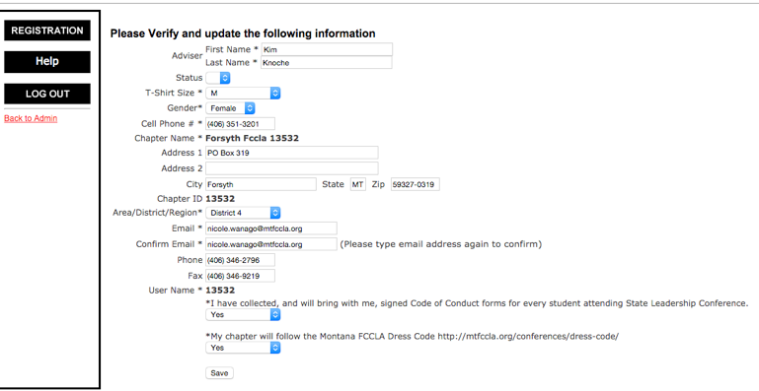

Adviser Registration

This box will automatically appear after the verification screen.  - Click ‘add adviser’  - Select ‘attending’  - Enter participant type, gender, and email | 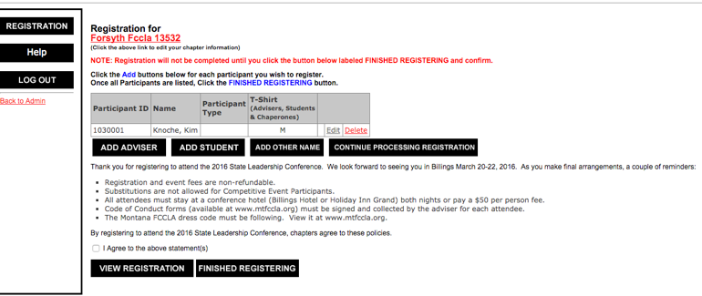
- Indicate any special needs.  - Click next | 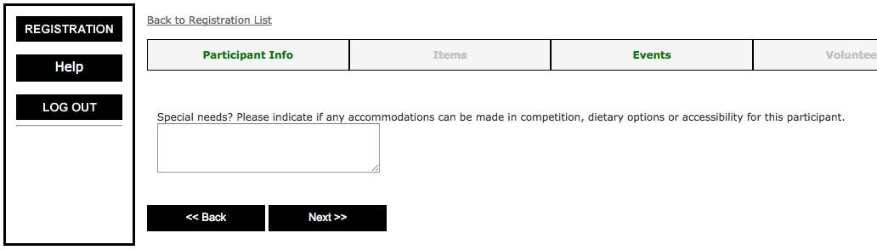
- Confirm information  - Click ‘finish participant’ | 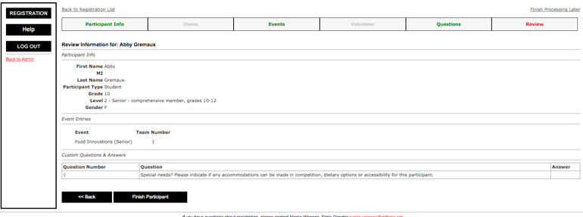

Member Conference & Event Registration

Step one:
Click ‘add student
I find it easiest to leave the first and last name blank.  Click search. | 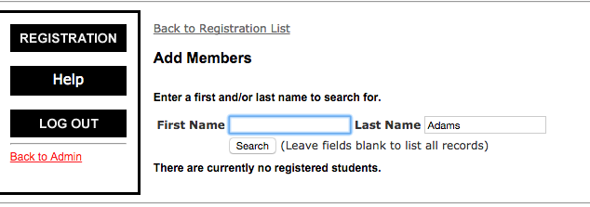
Step two:
For each person attending, enter their:  - Participant type:  - Student  - Current State Officer  - Incoming State Officer  - Voting Delegate  - Click continue (at the bottom) | 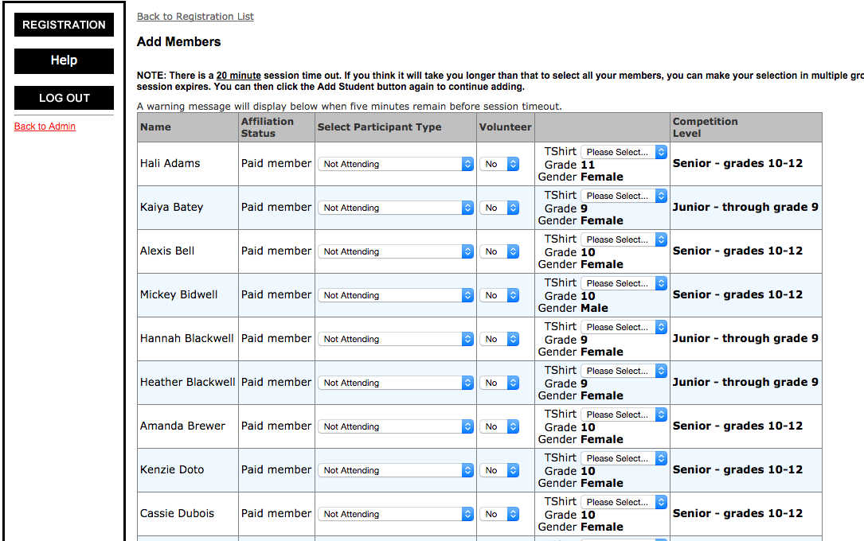
Special Notes:
- The name spelling, grade level, gender and competition level information is directly from the membership database. If anything is incorrect, log into the membership system to request a change.
- Only paid members will appear. Additional members may be added at any time in the membership affiliation system https://affiliation.registermychapter.com/fccla#. Their membership must be paid via credit card. Once paid, they can be registered for the conference. If their name does not immediately appear in conference registration, contact Nicole.
- Per the Montana FCCLA Constitution, each chapter MUST have two voting delegates or registration cannot be finalized.

Step Three:
This screen will automatically then appear.  - Review the participant’s information  - Click next | 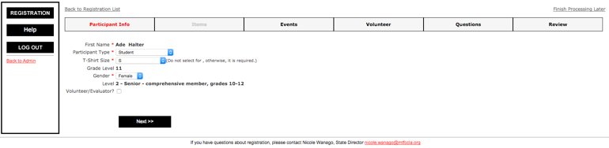
Step Four:
This screen includes all student participation options.  - STAR Events  - Skill Demonstration Events,  - Capture Crew  - STAR Event Room Timer  - Skill Demonstration Event Evaluator  - Awareness Session Presenter  - Leadership Seminar  - Place a check box in the student’s event(s)  - If the student is a member of a team, make sure the team number matches per team per category.  - If there is more than one team in a category, update the team number to be 2 for the second team.  - Click next | 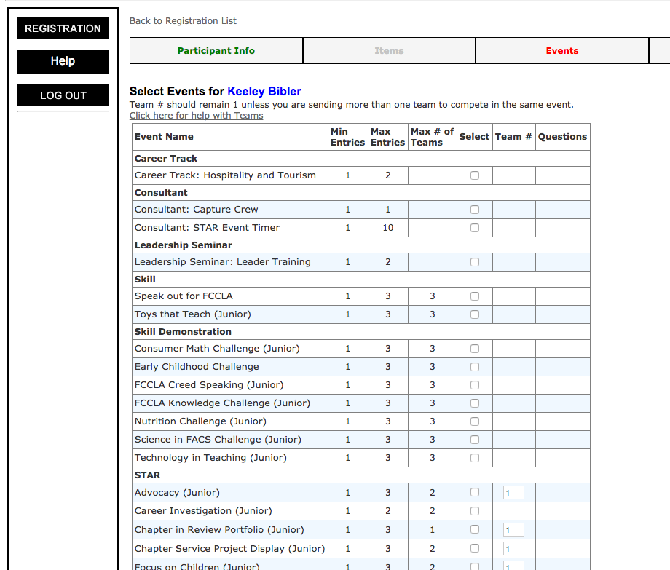
Special Notes:
- Only events the individual is eligible to enter, based upon category type will appear.
- If a team is comprised of students in both the juniors and senior categories, please contact Nicole for assistance registering them.
- View the Montana FCCLA Competitive Events Manual for STAR and Skill Demonstration Event eligibility guidelines.
- Every member attending must be participating in something on this screen. Exceptions include: Current or Incoming State Officer or individuals conducting approved Awareness Sessions.

Step Six:
If the student has any special needs impacting diet, accessibility or competition indicate what accommodations can be made.

Step Seven:
Confirm the participant information is correct.
- If yes, click “finish participant”
- If not, click ‘back”

Event selection steps 3-7 will automatically be repeated for each participant entered in step 2.
Step Eight:
Once events for all students have been entered, this screen should automatically appear.  - If not, click on ‘back to registration list’ (top left) from the screen you are on  - Check the ‘I agree to the above statements’  - Click ‘view registration’ | 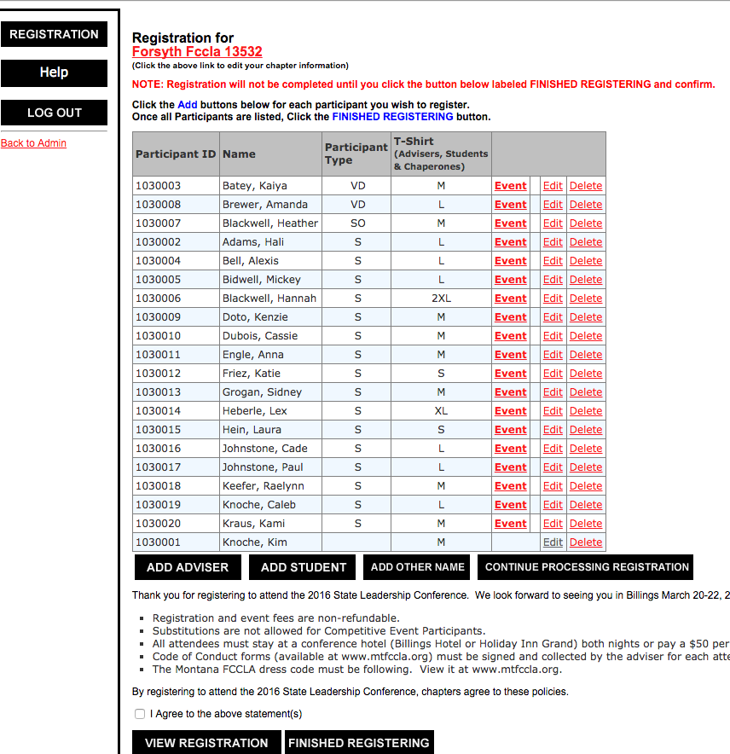
Review the ‘no event’ section in the middle to ensure all participants are registered for an event.  Review the ‘event/name’ at the bottom to ensure each student is registered for the correct event and teams are correct (look at team numbers).  If changes need to be made to a registered student:  - Click ‘back to registration list’ at the bottom  - Click ‘edit’  - Update the individual’s information (be sure to click through all prompts and ‘finish participant’  To add additional students  - Click ‘back to registration list’ at the bottom.  - Click ‘add student’  - Complete steps 2-7. | 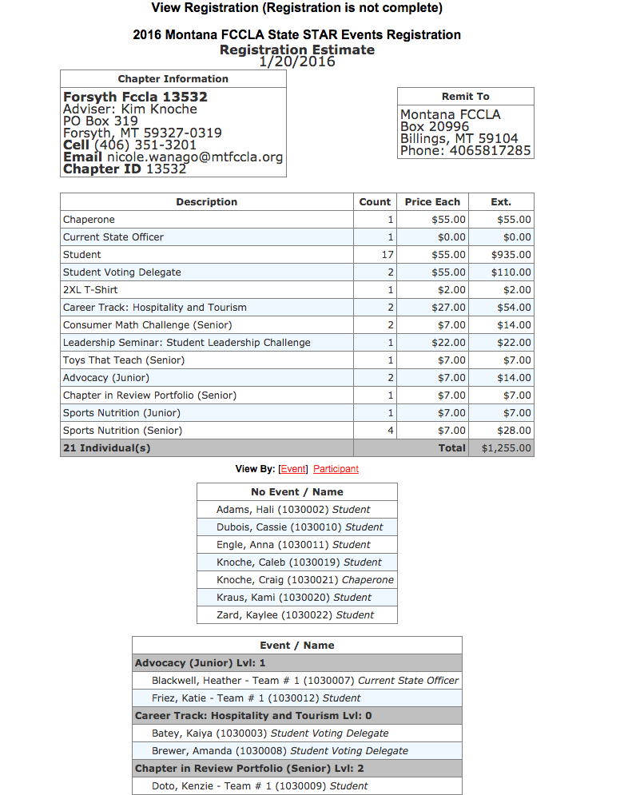

Chaperones

If this screen does not appear, click on “back to registration list” (top left) from the screen you are on.

- Click ‘add other name’ (black box at bottom)

- Add their name  - Participant type: Chaperone  - Gender  - Click volunteer/evaluator  - As a reminder, for the conference to be a success we rely upon the assistance of every adult in attendance.  - Click next | 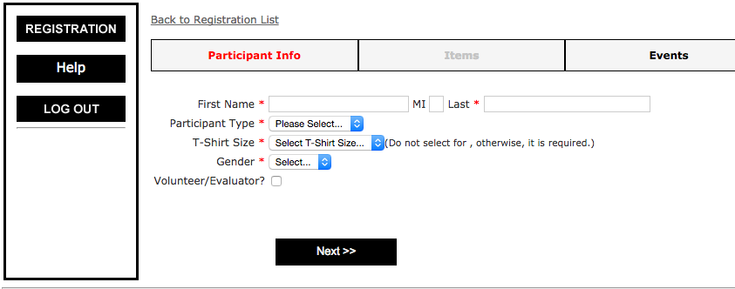
This screen allows you to identify what volunteer position your chaperone prefers.  - Only email is required (if you don’t have their email, use yours). Other contact information is optional.  - Comments: optional area to leave comments about this individual’s preferences  - Select which volunteer position is preferred. We will make every attempt to honor the request. Please keep in mind that over 100 event volunteers are needed! Advisers will be contacted in advance of SLC regarding their volunteer roles.  - Select the top 3 STAR or Skill Demonstration events the chaperone is most likely interested in evaluating.  - Click next. | 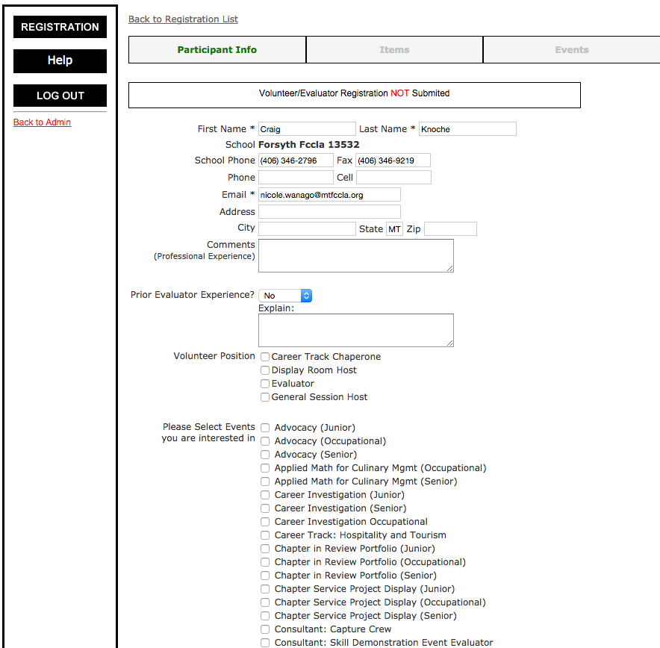
- Indicate any special needs.
- Click next.
- Confirm information.
- Click ‘Finish adding other’

Finalize Registration & Invoice

- Click on “Continue Processing Registration” (black box)
- If additional questions need to be answered for any participant, it will automatically guide you through prompts to finalize their individual registration.

- Click ‘finished registering’
- Click print the invoice (in red at the bottom of the screen)
- If paying by credit card, click the PayPal button to pay.
- Print 3 copies
  - One for you
  - One for your business manager
  - One to send to Connie with payment

Submit payment:
Connie Dempster, Bookkeeper
Box 20996
Billings, MT 59104

All chapters must be paid in full by March 10, 2017.

What if I need to make changes to my registration?
- Changes can be made at any time until registration closes on February 8.
- Log into the system and follow the prompts (as indicated above) to make any necessary changes.
- IMPORTANT: Click ‘finalize registration’ for change to occur. Print and submit an updated invoice to your business office.

